Quick and Dirty Overview videos:
- Part 1: https://drive.google.com/file/d/1TmrF7iEEy6URQmsxkQCLP72AKw3iEbLZ/view
- Part 2: https://drive.google.com/file/d/1LwlUYGz5VVeZjazzw8ToT378qcOKPUK8/view
- Part 3: https://drive.google.com/file/d/1_AHIErwyg8N6D7GTaFQzjTx3mskPZA45/view
- Part 4: https://drive.google.com/file/d/1tqkZOZkxeUqQOs67N_3geL9UN8VDFDih/view

Included in this guide:
- How to View, Respond and Delete Alerts (p. 1)
- How to Send a System Alert from Alerts Window (p. 5)
- How to Send a Service Entry as a System Alert (p. 7)
- Sending Non-Services in a Staff Alert EX: Demographics Page (p. 9)
- How to Archive messages & View Sent Messages (p. 11)
System Alerts: System alerts are system generated alerts regarding added/removed tasks, upcoming/overdue tasks, new client assignments, etc.
Staff Alerts: Staff alerts are messages from other staff within myEvolv.

How to View, Respond, and Delete Alerts
- To open a list view of System and Staff Alerts, click the bell in the upper right-hand corner of the screen.
- To close the list view of System and Staff alerts, click the x in the upper right-hand corner of the window.
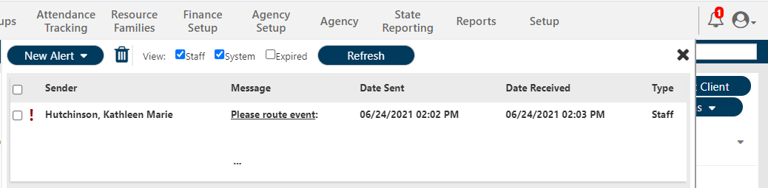
- When you first open the Alerts Window list, both System and Staff Alerts will be listed in date order with newest on top.
- Far right column indicates if an alert is a System or a Staff alert.
- Unread/Unopened alerts will show in a bold font.
- Alerts sent with High Importance will have an exclamation point!
Alerts Window Tools:
New Alert: Click open options of Alerts to send within myEvolv
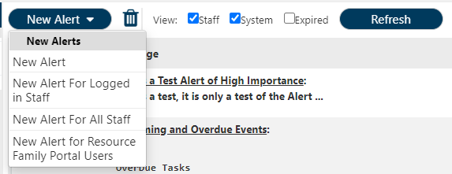
Trash Icon: Once an alert is selected, it can be deleted by clicking the trash icon
View: Staff/System: The alerts list can be filtered to view only Staff Alerts or only System Alerts by unchecking either
Refresh: To check for any incoming alerts since opening Alerts Window, click Refresh

Viewing an Alert
To view an alert, simply click the line to open it.
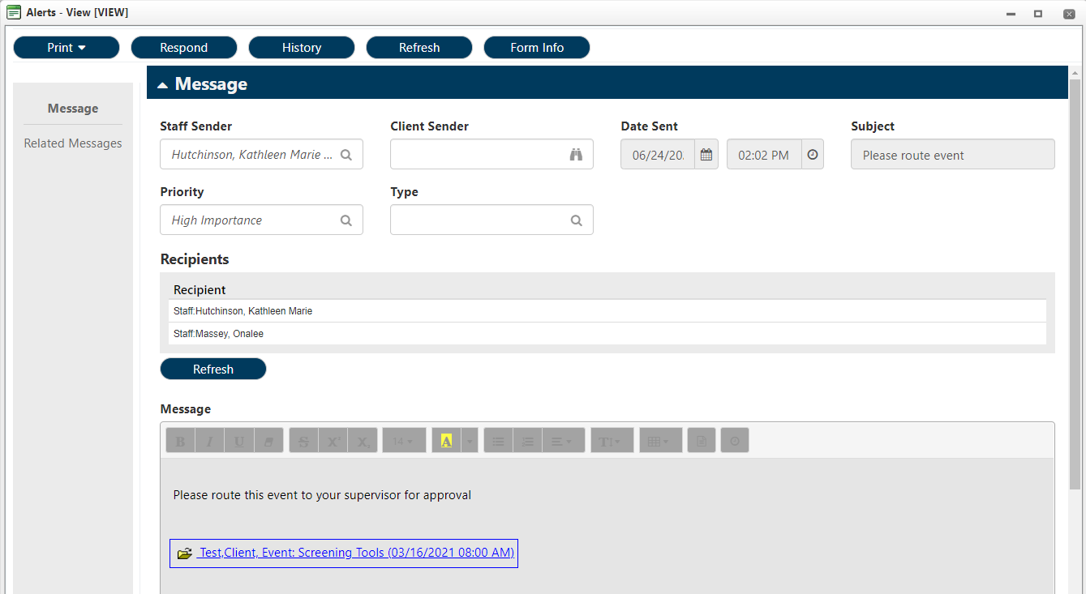
Responding to a Staff Alert
*System alerts will have a blank Staff Sender field and Responses will not be seen by anyone.
- When you open a staff alert a window pops up to show Sender, Date Sent, Subject, Priority, Recipients and Message.
- If a response is necessary, Click Respond at the top.
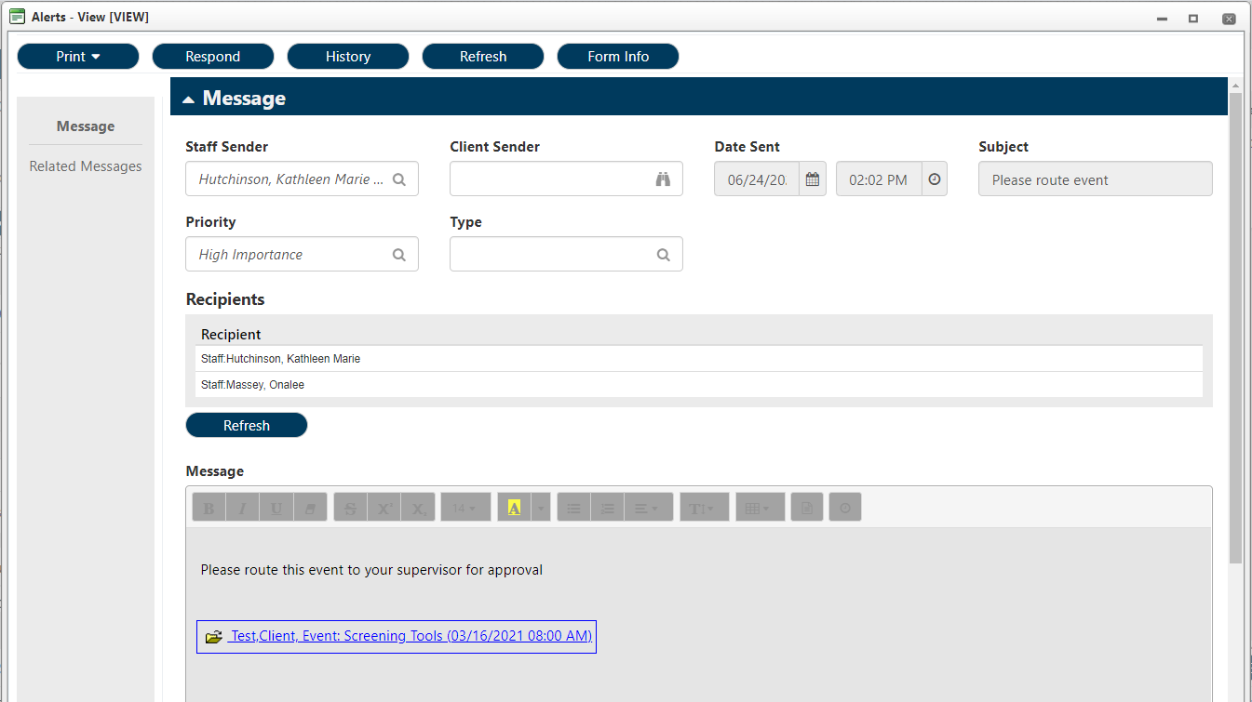

- Response Will be Sent To: This field will automatically populate with the staff who sent you the alert and cannot be changed
- Priority: Select High Importance or Low Importance
- Subject: This field will automatically populate and cannot be changed
- Recipients: Additional staff or WorkGroup can be included in response
- Message Text: Include your message within the messages field, like you would an email
Click Send
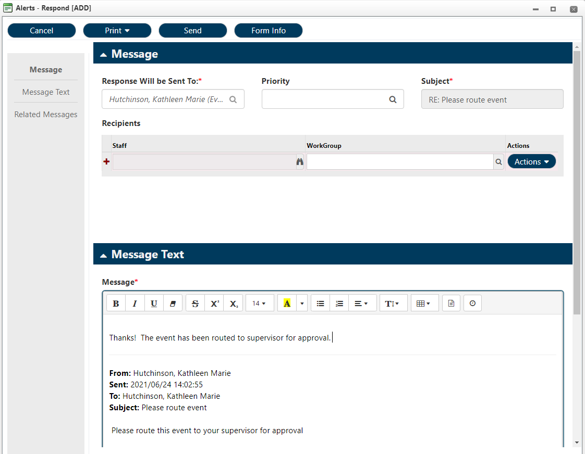

Deleting an Alert
To delete an alert after you are finished with it, click the check box next to the correct alert and then click the trash icon.
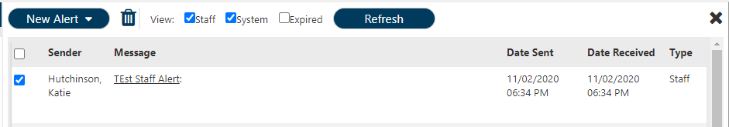

How to send an Alert from Alerts Window
Click the Alerts Bell in the upper right-hand corner of your screen to open alerts menu.
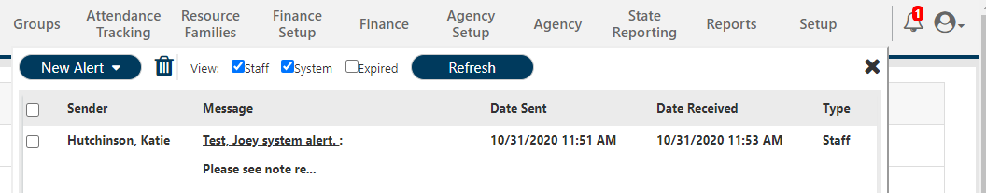

Click New Alert > Select type of New Alert
*For this guide, we are using the general New Alert
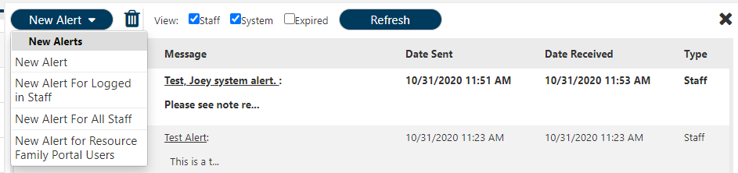

New Alert window will pop up.
- Sender: This name auto populates as worker signed in (this is you) and cannot be changed
- Priority: Select High or Low Importance
- Subject: Enter subject line of the alert
- Recipients: Select either staff or WorkGroup. Multiple staff or workgroups can be selected
  - If sending System Alert to one Staff member, use binoculars to select appropriate staff
  - If sending System Alert to a WorkGroup, use magnifying glass to select group
- Message: Include any information notes necessary for recipients.
Click Send.
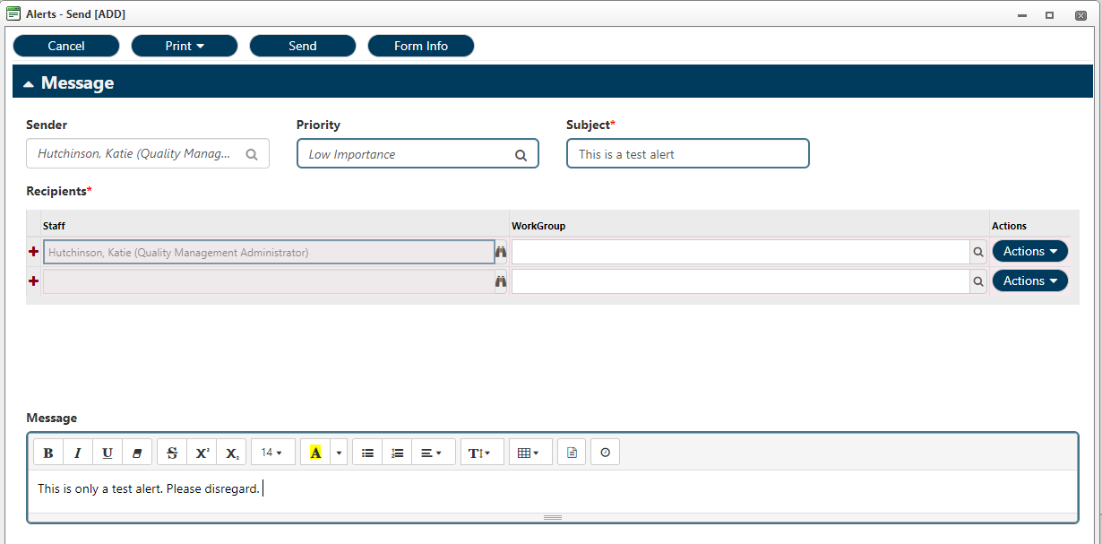
Alert will now appear in recipients’ Alerts Window.
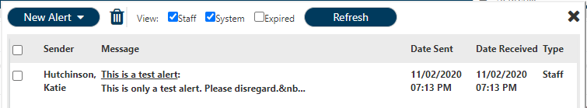

Sending a Service Entry/Ticket as a Staff Alert
*The following process can be used for any service entry/group note/treatment plan/etc entered in myEvolv.
Breadcrumbs: Client > My Client > Service Management > Service Entry
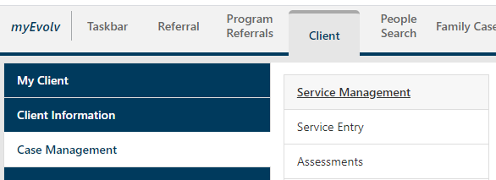

Select and open the event you wish to send as a system alert
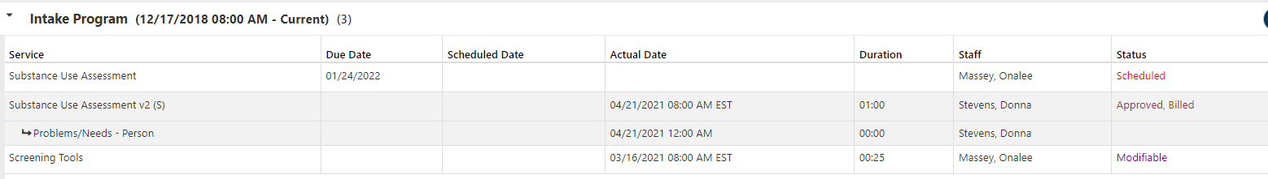

Click Send Alert.

Complete Alerts message:
- Sender: This field cannot be edited
- Priority: Use magnifying glass to select High or Low Importance
- Subject: Enter subject line for alert
- Recipients: Select a staff or workgroup
- Multiple staff can be selected and multiple workgroups can be selected, however, a workgroup and a staff cannot be selected together.
- Message: A link to the service entry will be included in the message field. Add any additional notes.

Click Send.
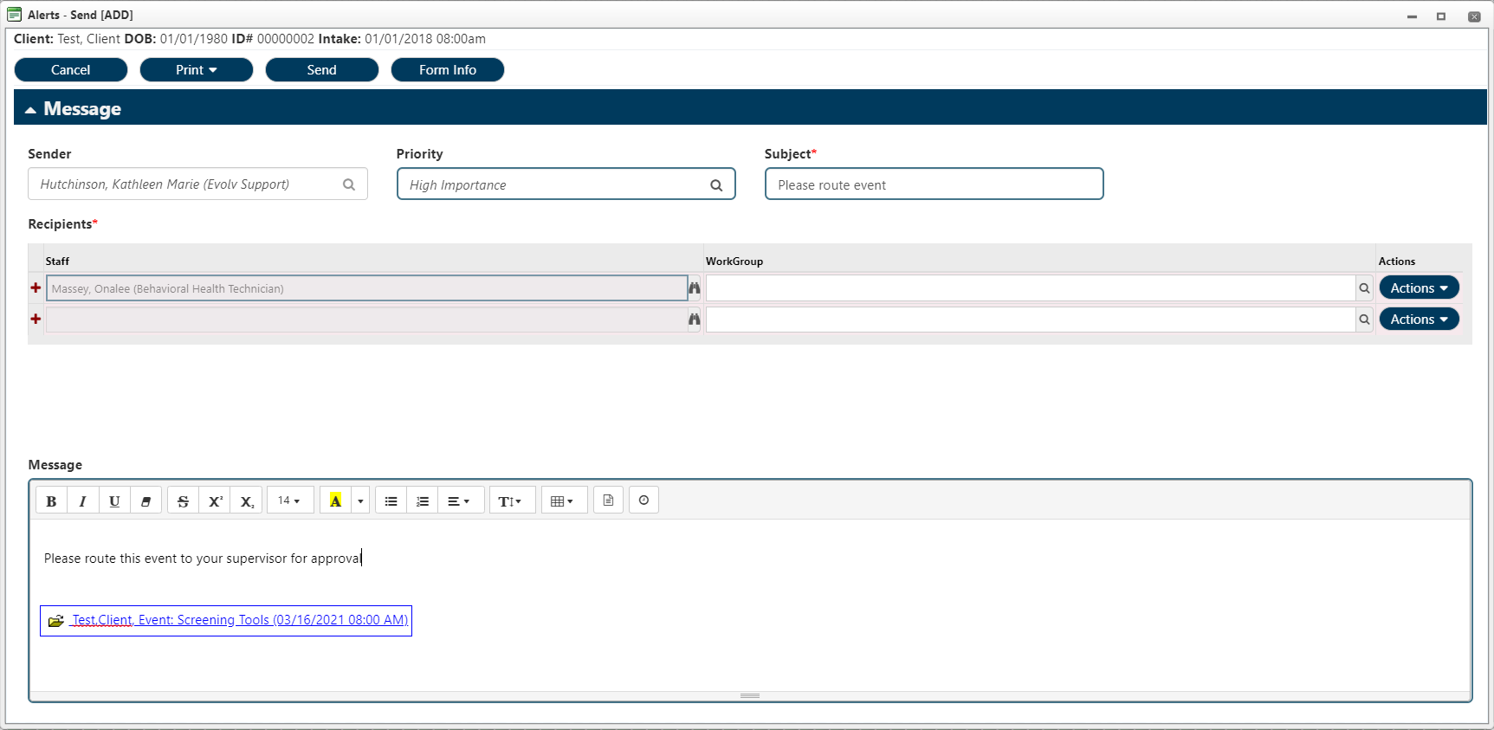

Alert will now appear in recipients’ alerts window
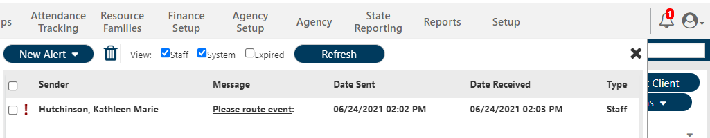

Sending Non-Service pages in a Staff Alert EX: Demographics Page
When a client reports a change in address, emergency contact, etc., this update can be communicated to another staff or workgroup via a Staff alert.
Breadcrumbs: Client > Client Information > Personal Information > Demographics
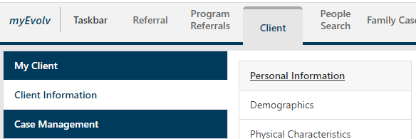

Update and save necessary changes to demographics information.
When you are ready to send the alert, click Send Alert.
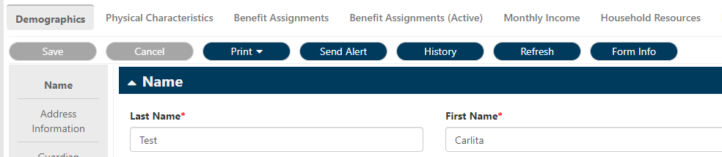

- Sender: This field cannot be edited
- Priority: Use magnifying glass to select High or Low Importance
- Subject: Enter subject line for alert
- Recipients: Select a staff or workgroup
  - Multiple staff can be selected and multiple workgroups can be selected, however, a workgroup and a staff cannot be selected together.
- Message: A link to the Demographics page will be included within the message field. Add your notes
Click Send.
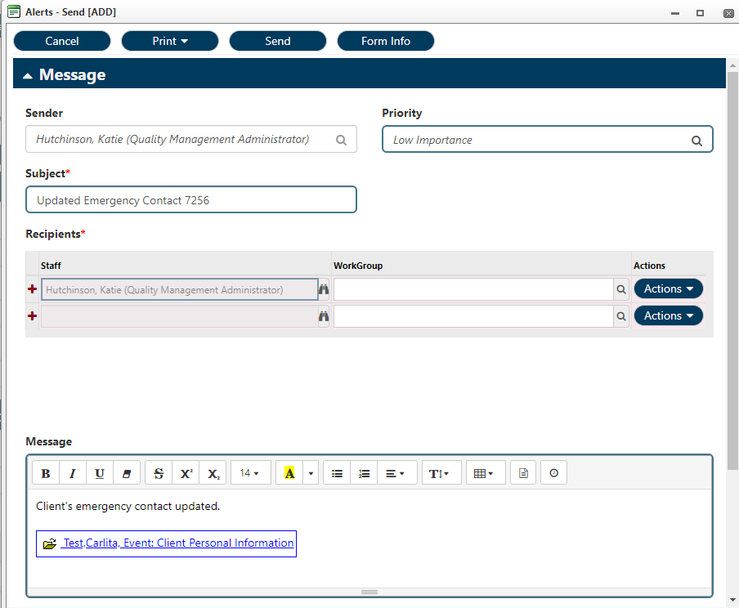

Alert will now appear in recipients’ alerts window.
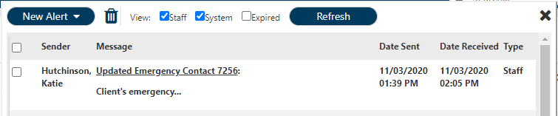

How to Archive messages & View Sent Messages
Breadcrumbs: Taskbar > Alerts > Alerts > Alerts
This view will provide all of the capabilities offered with the pop out box from the Alerts bell, with a couple additional features.
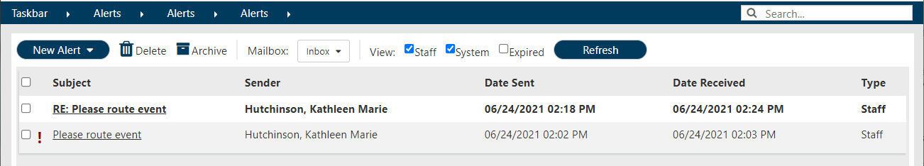
How to Archive Alerts Messages
To keep a message for future follow up but remove it from your in box, click the box next to the message you wish to archive.
Click Archive.
The message will disappear from your inbox.
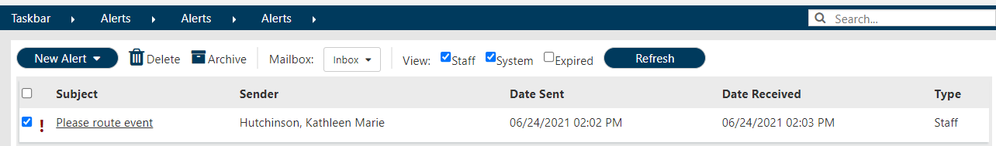

How to view Archived Messages
Click the down arrow next to Inbox to open drop down menu.
Click Archive to view Archived messages.
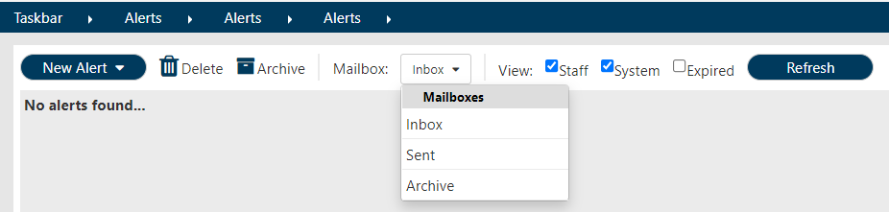

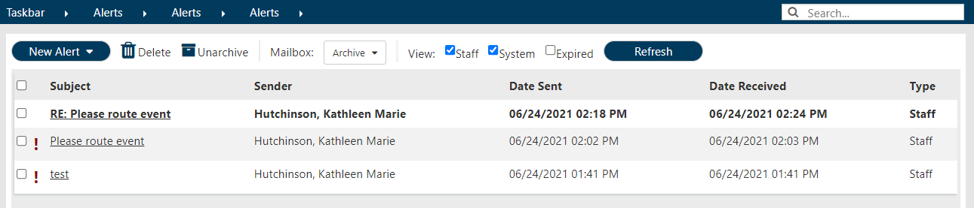

How to view Sent Messages
Click the Mailbox dropdown menu and select Sent.
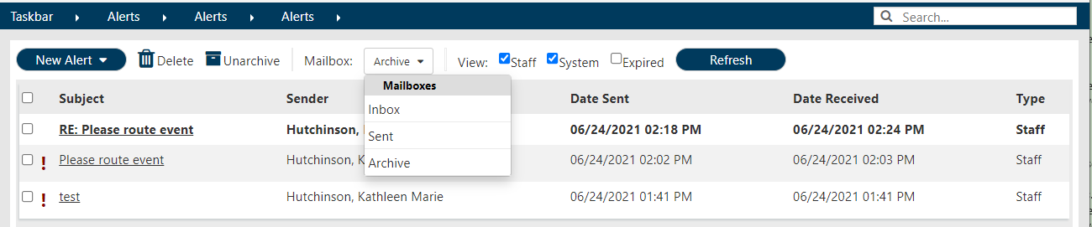

Sent messages will now be listed
